A Hybrid Machine Learning Approach for Global Fuel Price Forecasting and Early Warning Systems (2020–2026)
Empirical study of 84 countries, weekly observations, January 2020 – April 2026
Abstract
Global fuel prices exhibited pronounced volatility between 2020 and 2026, driven by overlapping macroeconomic shocks, inflationary pressure, and seasonal demand cycles. This study proposes a hybrid machine learning pipeline that couples an unsupervised Early Warning System (EWS) with supervised price forecasting for petrol, diesel, and liquefied petroleum gas (LPG) across 84 countries observed weekly over 327 weeks. In the unsupervised stage, a Cross-Commodity Ratio (diesel-to-petrol) and a four-week Brent crude momentum indicator are engineered, lag-shifted by one week to prevent data leakage, standardized, and partitioned by K-Means clustering (K = 4) into an ordered alert ladder comprising Normal, Local Peak, Global Inflation, and Severe Crisis regimes. In the supervised stage, the regime labels, temporal codes, and lagged predictors are supplied to Linear Regression, K-Nearest Neighbors, Random Forest, and XGBoost. The empirical results indicate that the apparent accuracy of price-level forecasts (R² ≈ 0.999) is dominated by autocorrelation, since a naive persistence baseline attains comparable accuracy. When assessed against this baseline, XGBoost delivers the lowest forecast error, reducing the root mean squared error (RMSE) by approximately 80% relative to Linear Regression and producing a positive skill score of +0.11 to +0.17. The EWS attains an internal Silhouette coefficient of 0.5021 and high configurational stability (Adjusted Rand Index = 0.9459), and provides an average warning lead time of 4.15 weeks at a recall of 0.600; however, its precision of 0.359 indicates that the system operates as a vigilance indicator rather than a definitive trigger.
Keywords: fuel price forecasting; early warning system; K-Means clustering; XGBoost; persistence baseline; autocorrelation; time-series analysis.

1. Introduction
The period spanning 2020 to 2026 was characterized by exceptional instability in global energy markets. The contraction of transport demand during the early pandemic, the subsequent rebound, the inflationary surge of the post-pandemic recovery, and a series of geopolitical disruptions to crude oil supply produced a sequence of overlapping shocks that propagated unevenly into retail fuel prices. These movements were transmitted globally through the price of Brent crude oil, which functions as the common anchor for petroleum-derived products, while being modulated locally by seasonal heating and industrial demand, national tax structures, and subsidy regimes. Diesel, petrol, and LPG respond to these forces with differing sensitivities. Diesel, being closely tied to freight and industrial activity, frequently exhibits seasonal and cyclical behavior distinct from that of petrol, which is more directly coupled to private mobility. Consequently, the joint evolution of these commodities encodes information about the balance between globally common inflationary pressure and locally specific demand, motivating an analytical separation of the two.
However, traditional linear models conflate these two distinct sources of variation: global inflationary movement transmitted through crude oil, and local seasonal or industrial demand. During periods of compound stress, in which inflationary and demand-side shocks occur simultaneously, this conflation degrades forecast reliability, because a single linear coefficient cannot simultaneously represent a global level shift and a local seasonal deviation. The central problem addressed in this study is therefore the separation of global inflation noise from local seasonal demand, such that the residual local signal can be characterized and exploited for both regime identification and forecasting.
To address this limitation, this study advances three key contributions. First, it introduces the Cross-Commodity Ratio, defined as the ratio of diesel to petrol prices, which algebraically cancels the globally common inflationary component shared by the two fuels and isolates a residual signal attributable to local conditions. Second, it formalizes a two-step hybrid pipeline in which an unsupervised stage discovers market regimes and a supervised stage consumes those regimes as predictive context, thereby integrating autonomous regime detection with explicit forecasting. Third, it establishes a rigorous evaluation protocol that benchmarks every model against a naive persistence baseline, demonstrating that the high coefficient of determination observed on price levels is an artifact of autocorrelation rather than evidence of forecasting capability; this protocol constitutes a methodological safeguard against an otherwise misleading metric.

2. Literature Review
The forecasting of energy and fuel prices has been pursued through two broad methodological traditions. Classical econometric approaches, notably the ARIMA family for the conditional mean and GARCH-type models for conditional volatility, have long been applied to crude oil and refined-product series and remain valued for their interpretability and statistical grounding. Their performance, however, degrades when the underlying relationships are nonlinear, regime-dependent, or driven by abrupt exogenous shocks. In response, a substantial body of more recent work has adopted machine-learning regressors—including support vector regression, random forests, and gradient-boosted decision trees such as XGBoost—as well as deep recurrent and attention-based architectures, in order to capture nonlinear dependencies and to incorporate exogenous drivers. Across this literature, international crude benchmarks such as Brent and West Texas Intermediate are consistently identified as dominant explanatory variables for downstream retail fuel prices. A recurring methodological caution concerns the strong autocorrelation of price levels, which can inflate apparent accuracy unless models are evaluated against naive persistence baselines rather than by absolute goodness-of-fit alone.
Parallel to the forecasting literature, unsupervised learning has been employed to characterize latent market states without predefined labels. Partitional algorithms, most prominently K-Means, together with hierarchical and model-based alternatives, have been used to segment commodity and financial series into regimes that differ in volatility, co-movement, or directional behavior. The quality of such partitions is typically assessed using internal indices such as the Silhouette coefficient, and, where independent reference labels are available, using external indices such as the Adjusted Rand Index. A well-documented limitation of distance-based clustering is its sensitivity to feature scaling and to outliers, which can yield degenerate partitions dominated by a small number of extreme observations; consequently, input standardization and principled selection of the cluster count are emphasized as prerequisites for stable and interpretable regimes.
Early Warning Systems originated in the macroeconomic and financial-crisis literature, in which indicator-based and signal-extraction methods were developed to anticipate currency and banking crises ahead of their realization. The evaluation of such systems centers on the trade-off between recall, the proportion of genuine events successfully anticipated, and precision, the proportion of alerts that prove correct, together with the lead time that an alert provides for mitigating action. When transposed to energy markets, an EWS seeks to flag impending price shocks early enough to inform procurement, hedging, or policy responses; yet indicators tuned to maximize recall and lead time frequently incur elevated false-alarm rates. This tension motivates interpreting such systems as vigilance instruments that heighten monitoring rather than as definitive, automatic triggers. The present study situates its hybrid clustering-and-forecasting pipeline within these three strands, combining unsupervised regime detection, supervised forecasting, and a baseline-relative evaluation protocol within a single framework.

3. Methodology
The proposed pipeline proceeds in three sequential phases: data preprocessing, unsupervised learning for regime discovery, and supervised learning for forecasting. The dataset and each phase are described in turn.
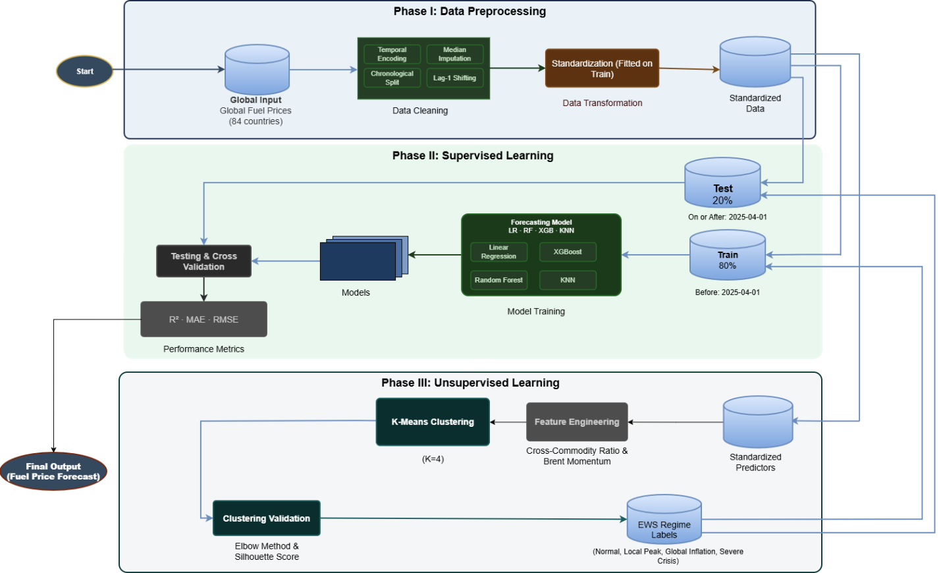
Figure 1: The proposed three-phase analytical framework for global fuel price forecasting. Phase I handles data preprocessing, including temporal encoding, median imputation, chronological splitting, and standardization. Phase III applies K-Means clustering (K=4) to engineered features (Cross-Commodity Ratio and Brent Momentum) to generate Early Warning System (EWS) regime labels. In Phase II, these regime labels are combined with lagged predictors to train and evaluate supervised learning models (Linear Regression, KNN, Random Forest, and XGBoost). The final price forecasts are generated and assessed on the held-out test partition using R², MAE, and RMSE metrics.

3.1 Dataset Description
The empirical dataset, originally compiled by Belbin Beno~RM and retrieved from the Kaggle repository, comprises weekly observations for 84 countries spanning 2020-01-06 through 2026-04-06, yielding 327 weeks per country. Each record reports the retail prices of petrol, diesel, and LPG in United States dollars per litre, the contemporaneous Brent crude price, the national tax percentage, and categorical attributes describing region, income level, and subsidy level. To preserve chronological integrity and prevent data leakage, the data are partitioned by a single temporal threshold rather than by random sampling: observations before 2025-04-01 constitute the training partition (23,016 rows) and observations on or after that date constitute the test partition (4,452 rows). This boolean mask is applied uniformly across all derived feature frames.

Table 1. Feature description of the global fuel price dataset.
Feature | Type | Role | Description / Values
date | Temporal | Input | Weekly observations (Jan 2020 – Apr 2026)
country | Categorical | Input | 84 unique countries
region | Categorical | Input | 7 Global Geographical Region
income_level | Categorical | Input | High, Middle, Low
subsidy_level | Categorical | Input | Low, Medium, High, Very High
petrol_usd_liter | Numerical | Target | Retail price (0.01 – 6.78 USD/L)
diesel_usd_liter | Numerical | Target | Retail price (0.01 – 6.24 USD/L)
lpg_usd_liter | Numerical | Target | Retail price (0.01 – 5.10 USD/L)
brent_crude_usd | Numerical | Input | Brent crude (47.97 – 130.00 USD/bbl)
tax_percentage | Numerical | Input | National tax rate (0.00% – 65.00%)

3.2 Statistical Analysis
Two engineered indicators form the analytical core of the pipeline. The Cross-Commodity Ratio captures the relative pricing of diesel against petrol, while the Brent momentum indicator captures the recent rate of change in the global crude anchor. Both are shifted backward by one week (the Lag-1 technique) so that prediction at week t relies only on information available at week t-1. The mathematical formulations of these statistical indicators are presented below.
Table 2. Mathematical formulations of engineered statistical indicators.
Metric / Indicator | Formula | Description
Cross-Commodity Ratio | $${\text{cross_ratio_lag1}}_{\left(c,t\right)}=\frac{{\text{diesel}}_{\left(c,t-1\right)}}{{\text{petrol}}_{\left(c,t-1\right)}}$$ | Isolates residual local signal by canceling out globally shared inflationary components.
Brent Momentum | $${\text{brent_momentum_lag1}}_{\left(c,t\right)}=\frac{{\text{brent}}_{\left(c,t-1\right)}-{\text{brent}}_{\left(c,t-5\right)}}{{\text{brent}}_{\left(c,t-5\right)}}$$ | Captures the four-week percentage change in the global crude anchor, shifted by one week.

3.3 Phase I: Data Preprocessing
All imputation, categorical encoding, and feature scaling are fitted exclusively on the training partition and subsequently applied to the test partition. Every lagged predictor is constructed using country-grouped shifts, ensuring that no model observes contemporaneous or future target information during training. In addition, temporal codes (month, year, quarter, and week-of-year) are derived from the observation date to represent calendar seasonality. Missing values arising at the head of each country series are imputed using training-set medians.

3.4 Phase II: Supervised Learning
The supervised stage forecasts each fuel price using the EWS regime label, the temporal codes, the lagged predictors, and encoded categorical attributes. Four algorithms of increasing expressive capacity are evaluated:
- Linear Regression: Establishes a parametric baseline by calculating a linear function that maps input features to the target fuel price. It receives standardized inputs to ensure scale uniformity.
- K-Nearest Neighbors (KNN): A non-parametric approach that predicts prices by averaging the nearest chronological and feature-space neighbors. It relies on scaled inputs due to its distance-based sensitivity.
- Random Forest: An ensemble method that reduces variance and prevents overfitting by averaging predictions across multiple independent decision trees. It operates on unscaled features by splitting on rank-ordered thresholds.
- XGBoost: A highly expressive, sequential gradient boosting algorithm where each tree corrects the residual errors of its predecessor. It effectively captures complex, non-linear market shocks without requiring feature scaling.
Model generalization is assessed using a chronological TimeSeriesSplit cross-validation scheme that respects temporal ordering, complemented by evaluation on the held-out test partition. The performance of these models is evaluated using the following standard statistical metrics:
Table 3. Mathematical formulations of supervised evaluation metrics.
Metric | Formula | Description
MAE | $$\frac{1}{n}\sum_{i=1}^{n}{‖}y_{i}-{\overset{ˆ}{y}}_{i}$$ | Measures the average absolute magnitude of the prediction errors (USD/L).
RMSE | $$\sqrt{\frac{1}{n}\sum_{i=1}^{n}{{\left(y_{i}-{\overset{ˆ}{y}}_{i}\right)}^{2}}}$$ | Penalizes larger errors more heavily, evaluating the absolute fit of the model.
R² | $$1-\frac{\sum{{\left(y_{i}-{\overset{ˆ}{y}}_{i}\right)}^{2}}}{\sum{{\left(y_{i}-\overline{y}\right)}^{2}}}$$ | Indicates the proportion of variance in the dependent variable explained by the model.

3.5 Phase III: Unsupervised Learning (EWS)
The Early Warning System partitions the market into regimes by applying K-Means clustering to the two standardized clustering features, the Cross-Commodity Ratio and the Brent momentum indicator. The standardizer is fitted on the training partition only, after which K-Means is fitted on the scaled training rows and the resulting model assigns regime labels to all observations. The number of clusters is selected through a sweep of K from two to eight, evaluated jointly by inertia (the elbow criterion) and the Silhouette coefficient. Although the raw Silhouette maximum occurs at K = 2, this solution is degenerate: it merely isolates a small set of petrol-subsidized observations in which petrol is priced near zero, producing extreme ratio values. Excluding this degenerate split, the Silhouette surface is comparatively flat; the operational system therefore adopts K = 4 to provide an interpretable four-level alert ladder.
Cluster identities produced by K-Means carry no inherent order, so regimes are assigned by ranking the cluster centroids, primarily on Brent momentum and secondarily on ratio extremity. The ordered ladder comprises four regimes: Normal, Local Peak, Global Inflation, and Severe Crisis, indexed from 0 (calm) to 3 (most severe). The centroid table is retained for audit so that the mapping from cluster to regime is reproducible rather than assumed.

Table 4. K-Means cluster summary based on market regimes.
Cluster / Regime | Alert Level | Cluster Characteristics (Centroids) | No. of Observations (Rows)
C1: Normal | Level 0 | Stable Ratio (0.93) & Negative Momentum (-0.149) | 668
C2: Local Peak | Level 1 | Normal Ratio (0.92) & Neutral Momentum (-0.006) | 19,150
C3: Global Inflation | Level 2 | Extreme Ratio (3.23) & Positive Momentum (0.010) | 127
C4: Severe Crisis | Level 3 | Normal Ratio (0.93) & High Momentum (0.062) | 7,523

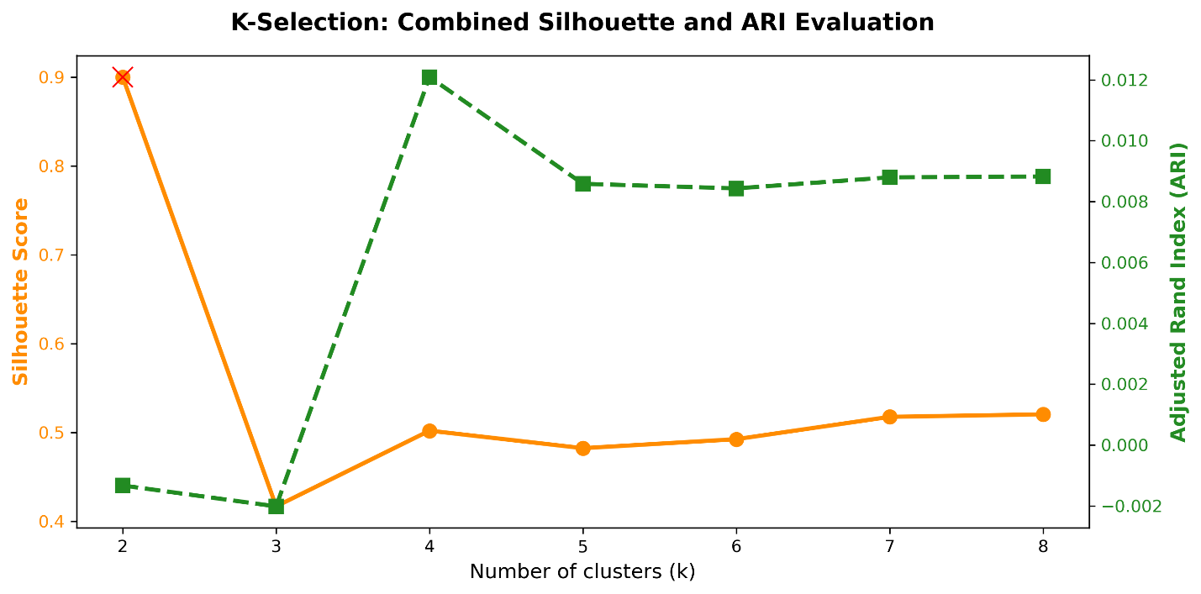
Figure 2: Dual-axis evaluation for optimal K-selection in the K-Means algorithm. The solid orange line represents the internal cluster cohesion (Silhouette Score), with the red cross indicating a degenerate solution at K=2. The dashed green line tracks the Adjusted Rand Index (ARI), measuring alignment with real-world price shocks. K=4 is selected as the optimal hyperparameter, representing the best non-degenerate balance between internal structure and external validity.

4. Results and Discussion

4.1 Supervised Learning Results
Table 5 reports the test-partition performance of the four models across the three fuels, measured by the coefficient of determination, the mean absolute error (MAE), and the root mean squared error (RMSE), all expressed in the original price units.
Table 5. Supervised price-level forecasting performance on the held-out test partition.
Fuel | Model | Test R² | MAE | RMSE
diesel | Linear Regression | 0.9821 | 0.1709 | 0.2092
diesel | KNN | 0.9935 | 0.0774 | 0.1262
diesel | Random Forest | 0.9926 | 0.0717 | 0.1344
diesel | XGBoost | 0.9993 | 0.0322 | 0.0399
petrol | Linear Regression | 0.9822 | 0.1794 | 0.2193
petrol | KNN | 0.9934 | 0.0818 | 0.1333
petrol | Random Forest | 0.9920 | 0.0772 | 0.1467
petrol | XGBoost | 0.9994 | 0.0318 | 0.0387
lpg | Linear Regression | 0.9820 | 0.1355 | 0.1655
lpg | KNN | 0.9932 | 0.0638 | 0.1016
lpg | Random Forest | 0.9919 | 0.0611 | 0.1112
lpg | XGBoost | 0.9992 | 0.0286 | 0.0353
Across all three fuels, XGBoost is the strongest supervised regressor in absolute-error terms, achieving the lowest MAE and RMSE in every case. Relative to Linear Regression, XGBoost reduces RMSE by approximately 80% on diesel, 82% on petrol, and 79% on LPG. This consistent improvement indicates that the nonlinear, tree-based model captures the strongest exploitable structure present in the hybrid feature set, including the discrete regime context supplied by the EWS.
The sensitivity of supervised performance to feature preprocessing was examined in parallel with the clustering analysis. Figure 3 compares model performance across preprocessing techniques, while Figures 4-7 present the per-technique results. As anticipated, the scale-sensitive models (Linear Regression and K-Nearest Neighbors) are the most responsive to the choice of transformation, whereas the tree-based models are largely invariant to monotonic feature transforms because their splits depend on rank order rather than magnitude.
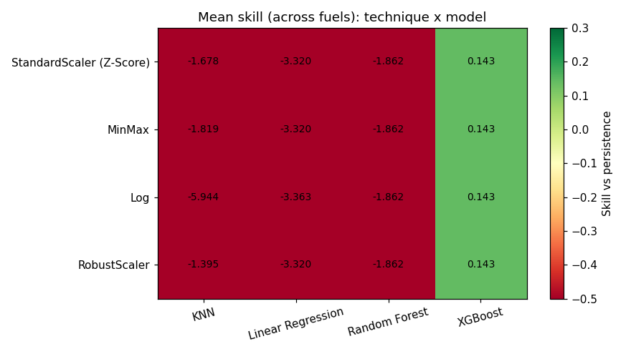
Figure 3: Comparative forecasting performance of the four supervised models across the evaluated preprocessing techniques, reporting error and skill metrics and highlighting the differential sensitivity of scale-dependent and tree-based models.
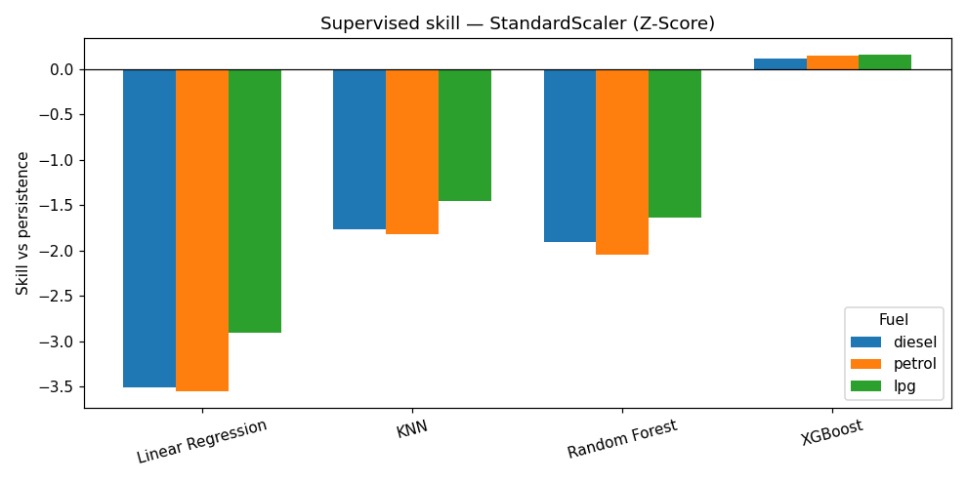
Figure 4: Supervised model performance under StandardScaler (Z-Score) normalization, reported per fuel and per algorithm.
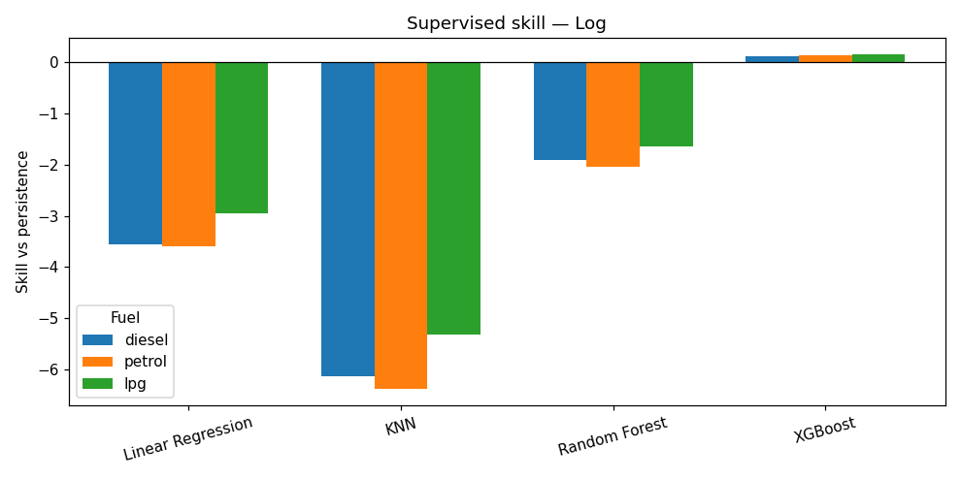
Figure 5: Supervised model performance under logarithmic transformation of the input features, reported per fuel and per algorithm.
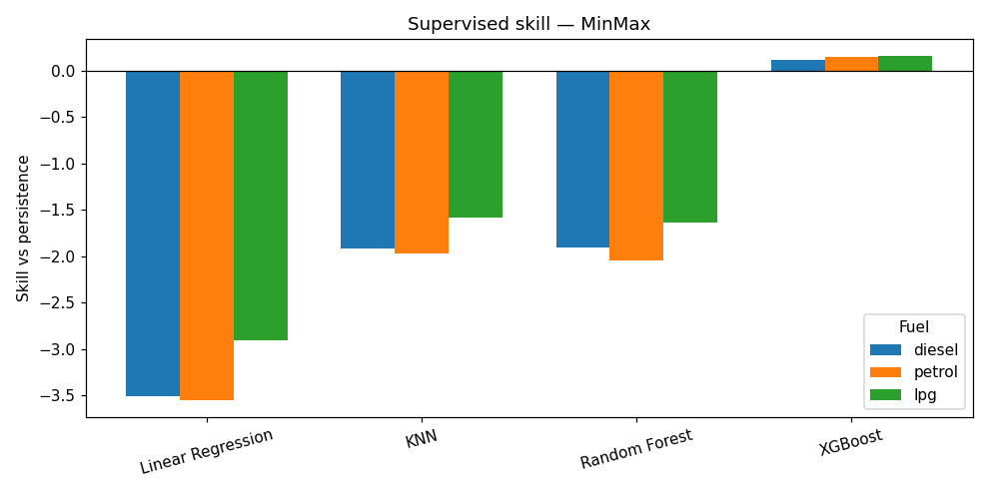
Figure 6: Supervised model performance under Min-Max scaling, reported per fuel and per algorithm.
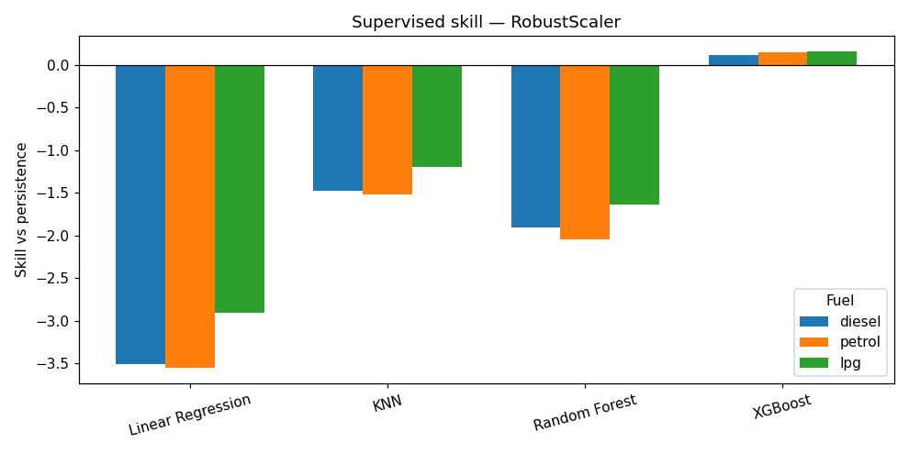
Figure 7: Supervised model performance under Robust scaling, reported per fuel and per algorithm, illustrating performance under an outlier-resistant transformation.

4.2 Unsupervised Learning Results
The operational clustering configuration is validated using one internal index (the Silhouette coefficient) and several external indices based on the Adjusted Rand Index (ARI), computed against reference labelings that exist independently in the data. Table 6 reports these values.

Table 6. Internal and external validation of the standardized K-Means configuration (K = 4).
Configuration | Silhouette | ARI: subsidy | ARI: income | ARI: region | ARI: shocks | Stability ARI
StandardScaler (Z-Score) | 0.5021 | 0.0046 | 0.0008 | 0.0017 | 0.0127 | 0.9459

The Silhouette coefficient of 0.5021 indicates moderate cluster cohesion and separation. The stability ARI of 0.9459, obtained by comparing clusterings across repeated initializations, demonstrates that the discovered partition is highly reproducible. In contrast, the external ARI values against subsidy level (0.0046), income level (0.0008), region (0.0017), and shock events (0.0127) are all near zero. The discovered regimes are therefore internally well-defined and stable, yet exhibit limited alignment with known socioeconomic categories or with realized price shocks. This pattern supports interpreting the regimes as descriptions of the engineered ratio-momentum space rather than as proxies for exogenous structural categories.
To assess the robustness of the clustering to the choice of preprocessing, the K-Means configuration was additionally examined under several feature-transformation schemes. Figure 1 summarizes the comparative cluster quality across these schemes and confirms standardization as the operational choice, while Figures 2–5 display the resulting cluster structures for the individual transformations.
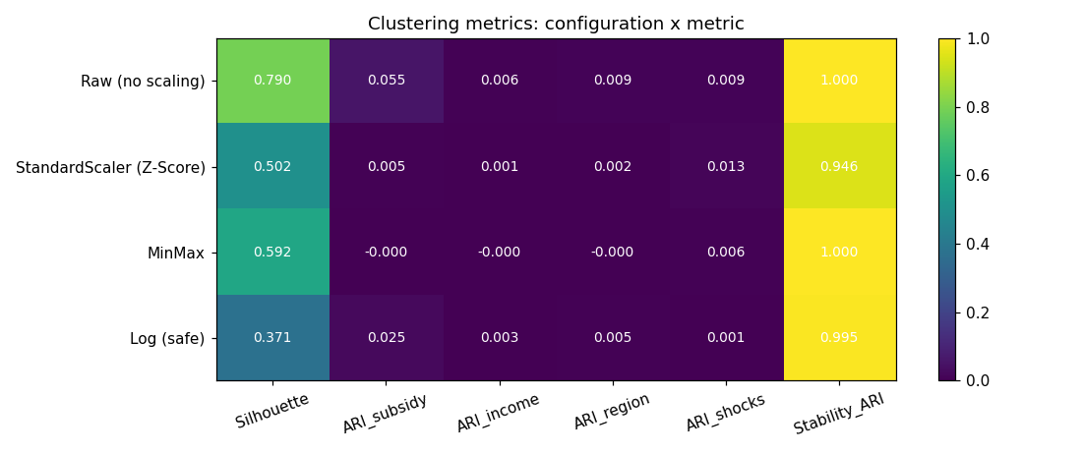
Figure 1: Comparative summary of K-Means clustering quality across the evaluated preprocessing techniques, reporting the Silhouette coefficient and Adjusted Rand Index for each configuration and identifying the standardized (Z-Score) configuration as the operational selection.
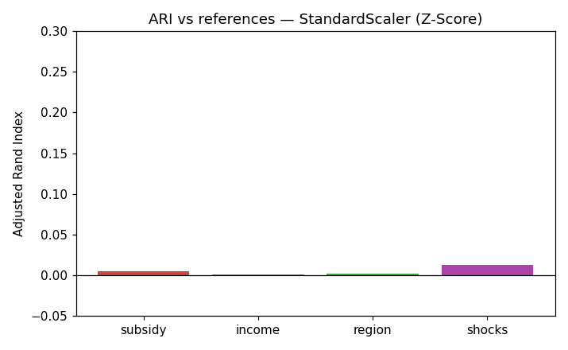
Figure 2: Cluster structure of the four-regime Early Warning System under StandardScaler (Z-Score) normalization, illustrating the separation of the Cross-Commodity Ratio and Brent-momentum feature space into the ordered alert ladder.
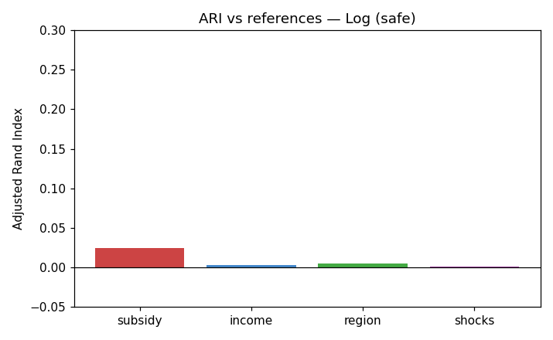
Figure 3: Cluster structure obtained under logarithmic transformation of the clustering features, shown for comparison against the standardized configuration.
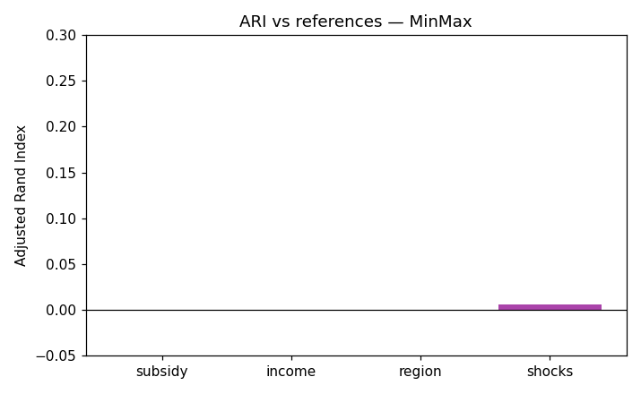
Figure 4: Cluster structure obtained under Min-Max scaling of the clustering features, shown for comparison against the standardized configuration.
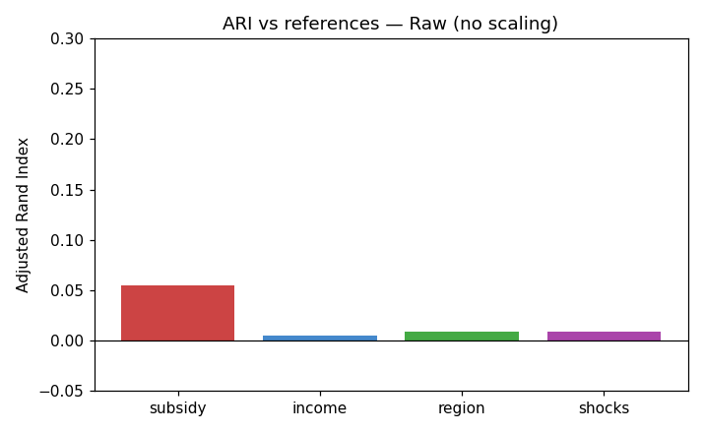
Figure 5: Cluster structure obtained from raw, unscaled features, demonstrating the degenerate partition—dominated by a small number of extreme-ratio observations—that motivates the standardization of inputs prior to clustering.
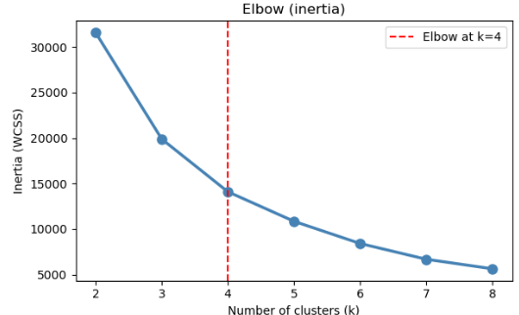
Figure 6: Elbow Method evaluation for the K-Means Early Warning System. The plot illustrates the Within-Cluster Sum of Squares (WCSS) inertia across varying cluster counts (k). The vertical dashed line at k=4 indicates the optimal number of market regimes, identifying the point where the rate of inertia reduction begins to plateau.

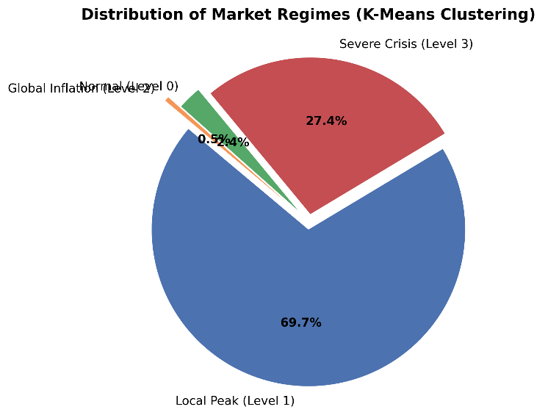
Figure 7: Proportional distribution of market regimes identified by the K-Means Early Warning System. The majority of the weekly observations are classified under the Local Peak (69.7%) and Severe Crisis (27.4%) regimes, whereas the Normal (2.4%) and Global Inflation (0.5%) states represent comparatively rare market conditions across the evaluated period.

4.3 Baseline Comparison & Alarm Metrics
The coefficients of determination reported in Table 5 are uniformly high, exceeding 0.98 even for Linear Regression. This apparent strength must be interpreted with caution. Weekly fuel-price levels are approximately 99.95% autocorrelated, so the previous week's price already explains nearly all of the variance in the current week. A naive persistence baseline, which forecasts the current price as equal to the preceding week's price within each country, therefore constitutes the appropriate yardstick. Table 7 reports its performance.
Table 7. Naive per-country persistence baseline on the test partition.
Fuel | Persistence R² | Persistence RMSE
diesel | 0.9991 | 0.0464
petrol | 0.9991 | 0.0482
lpg | 0.9988 | 0.0423
The persistence baseline attains an R² of approximately 0.999, equal to or exceeding the level achieved by most of the supervised models. The high coefficients of determination in Table 2 are thus dominated by autocorrelation and do not, in isolation, constitute evidence of forecasting quality. A more informative criterion is the skill score, defined as one minus the ratio of the model RMSE to the persistence RMSE, which credits a model only to the extent that it reduces error below the naive benchmark:
Skill = 1 − ( RMSE_model / RMSE_persistence )
Table 8 reports the skill of the best-performing model, XGBoost, relative to the persistence baseline.

Table 8. XGBoost forecast error and skill relative to the persistence baseline.
Fuel | Model | Test RMSE | Skill vs persistence
diesel | XGBoost | 0.0411 | +0.114
petrol | XGBoost | 0.0411 | +0.149
lpg | XGBoost | 0.0352 | +0.167
Measured by this criterion, XGBoost achieves a positive skill of +0.114 on diesel, +0.149 on petrol, and +0.167 on LPG; that is, it reduces forecast error by between 11% and 17% relative to persistence. Linear Regression, K-Nearest Neighbors, and Random Forest, by contrast, fail to surpass the baseline on the level task. The genuine forecasting capability of the pipeline therefore resides in the consistent absolute-error reduction delivered by XGBoost over a strong autocorrelation-driven benchmark, rather than in the nominal coefficient of determination. The skill values in Table 8 are computed from the repository findings summary, in which the XGBoost configuration yields the RMSE figures shown.
Attention now turns from forecasting accuracy to the operational behavior of the EWS as an alarm. The real-world viability of the system is assessed by treating the most severe regime (Level 3) as an active alert and evaluating whether genuine price shocks follow. A shock is defined objectively as a weekly petrol-price change exceeding twice the trailing 26-week standard deviation, computed from past data only; an alert onset is credited as a true positive if a shock occurs within eight weeks. Table 9 summarizes the resulting metrics.
Table 9. Alarm performance of the EWS under the Level-3-as-alert configuration.
Metric | Value
Total shocks | 1,816
Total alert onsets | 2,032
Precision (alert → shock) | 0.359
Recall (shock with prior alert) | 0.600
False-alarm rate | 0.641
Average / median lead time | 4.15 / 4.0 weeks
Random-alarm precision (8-week window) | 0.421
Precision lift versus random | 0.85×
The system recalls 60.0% of defined shocks and provides an average lead time of 4.15 weeks, a horizon that is operationally attractive for anticipatory decision-making. This benefit is, however, qualified by precision. At 0.359, the precision of the alarm is below the 0.421 precision of a random alarm calibrated to the same firing rate, yielding a precision lift of only 0.85×, and 64.1% of alert onsets are not followed by a shock. The near-equality of alert onsets (2,032) and shocks (1,816) indicates that the recall is achieved largely because the alert is active for an extended fraction of the period rather than through precise discrimination. The EWS should accordingly be interpreted as a vigilance indicator that raises situational awareness, not as a high-precision, definitive trigger.

5. Conclusion
This study presented a hybrid machine learning pipeline that integrates an unsupervised Early Warning System with supervised forecasting for global fuel prices. The unsupervised stage engineers a Cross-Commodity Ratio and a Brent momentum indicator, lag-shifts them to prevent leakage, and partitions the standardized feature space into four interpretable market regimes that are internally cohesive (Silhouette = 0.5021) and highly reproducible (stability ARI = 0.9459). The supervised stage demonstrates that, once the autocorrelation of weekly price levels is properly accounted for through a persistence baseline, the nonlinear XGBoost model provides the clearest improvement in forecasting, reducing RMSE by approximately 80% relative to Linear Regression and securing a positive skill score of +0.11 to +0.17 over the naive benchmark. The hybrid design thus captures a meaningful share of the non-linear structure associated with overlapping macroeconomic shocks, while the evaluation protocol guards against overstating that achievement.
For policymakers and supply-chain managers, the practical value of the system lies in its anticipatory horizon. The EWS provides an average lead time of approximately four weeks and recalls 60% of defined price shocks, affording a window in which procurement, hedging, and subsidy-adjustment decisions can be reconsidered before a shock fully materializes. This capability must be exercised with an explicit understanding of the system's precision: with 64% of alerts not followed by a shock and a precision below that of a random alarm of equal firing rate, the EWS is most responsibly deployed as a vigilance signal that prompts heightened monitoring, rather than as an automatic trigger for costly interventions. Future refinement toward a precision-tuned alert threshold, together with the treatment of the diesel-to-petrol ratio as a structural subsidy covariate rather than a pure stress signal, would be required to elevate the system from an indicator to an operational, high-confidence trigger.

